
COUNTY GOVERNMENT OF KIAMBU
Department of Finance, ICT and Economic Planning
CITIZEN BUDGET
FINANCIAL YEAR 2025/2026
Promoting Sustainable and Inclusive Growth for Socio-Economic Development
Kukuza Ukuaji Endelevu na Uliojumuisha kwa Maendeleo ya Kijamii na Kiuchumi
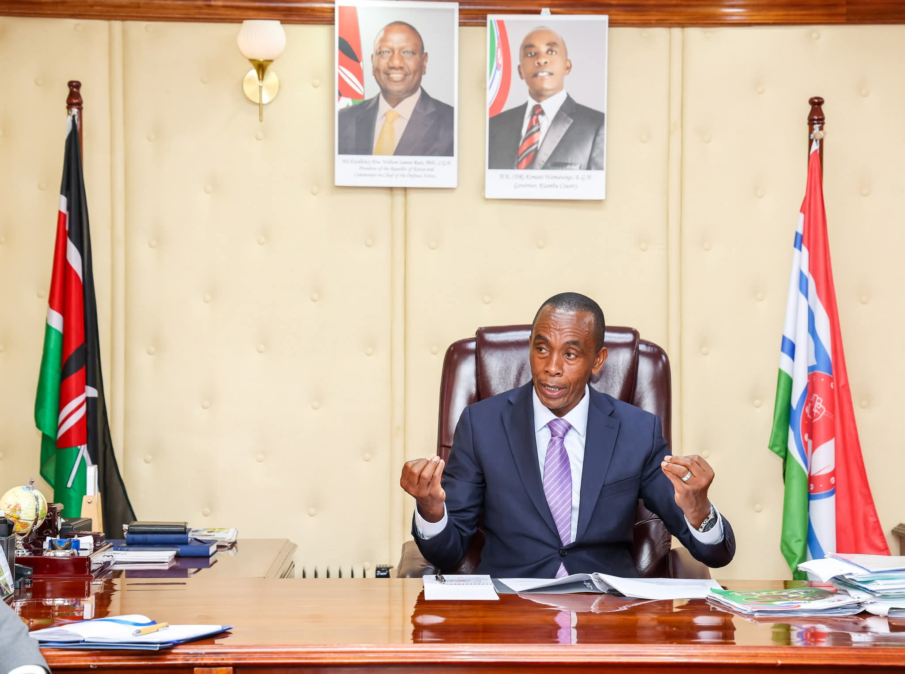

FOREWORD
This Citizen Budget presents a simplified overview of the County Government's Budget for the Financial Year (FY) 2025/2026. It highlights the County's expected sources of revenue, planned expenditure, and key development priorities, in clear and easy-to-understand language.
It has been prepared in accordance with Section 131(6) of the Public Finance Management Act, 2012, which requires the County Executive Committee Member for Finance to ensure that approved budget estimates are published in a form that is clear, easily understood, and readily accessible to the public.
“Bajeti hii ya Mwananchi inatoa muhtasari uliorahisishwa wa Bajeti ya Serikali ya Kaunti kwa Mwaka wa Fedha (FY) wa 2025/2026, ikiangazia vyanzo vya mapato, matumizi yaliyopangwa, na vipaumbele muhimu vya maendeleo.”

NANCY KIRUMBA
CECM – Finance, ICT and Economic Planning

- BUDGET AT A GLANCE FY 2025/2026 | BAJETI KWA MUHTASARI FY 2025/2026
COUNTY RAISES  KSh 7.98B  Own-source revenue  Mapato ya Kaunti | NATIONAL SHARE  KSh 13.07B  Equitable share  Mgao wa Kitaifa | DONOR FUNDING  KSh 2.76B  Other allocations & grants  Ruzuku na mgao mwingine

Source | Amount | Share
Own-source revenue | KSh 7.98B | 33.5%
National equitable share | KSh 13.07B | 54.9%
Other national & donor allocations | KSh 2.76B | 11.5%
TOTAL | KSh 23.81B | 100%
Kwa kila KSh 100 ya bajeti, takribani KSh 55 hutoka kwa Serikali ya Kitaifa, KSh 34 hukusanywa na Kaunti, na KSh 12 hutoka kwa mgao/ruzuku nyingine.

Proportion of expected source of revenue for FY 2025/2026

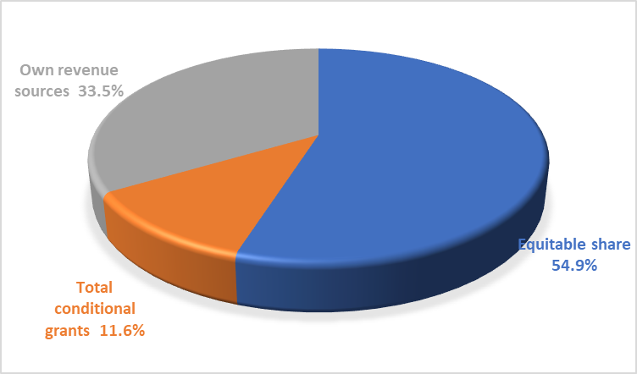

2.0 EXPENDITURES
The total budget for FY 2025/2026 amounts to Ksh 23.81billion. comprising KShs. 15.91 billion (67 percent) allocated for recurrent expenses and KShs. 7.89 billion (33 percent) earmarked for development projects .
Total Budget FY 2025/2026 Kshs 23.81 billion
Recurrent Expenditure Kshs 15.91 billion-67% of total budget(Huduma za kila siku)
Development Expenditure Kshs 7.89 billion-33% of total budget(Miradi ya maendeleo)

2.1 How the Money will be spent/Fedha itatumika wapi?
County Entity | Recurrent | Development | Total | % of Total Budget
County Assembly | 1,282,416,186 | 100,000,000 | 1,382,416,186 | 5.81
County Executive | 509,104,850 |  | 509,104,850 | 2.14
County Public Service Board | 90,740,688 |  | 90,740,688 | 0.38
Finance, Economic Planning and ICT | 1,626,602,281 | 240,000,000 | 1,866,602,281 | 7.84
Water, Environment and Natural Resources | 564,543,764 | 500,000,000 | 1,064,543,764 | 4.47
Health Services | 7,334,633,768 | 735,000,000 | 8,069,633,768 | 33.90
Roads, Transport and Public Works | 754,316,024 | 1,885,699,120 | 2,640,015,144 | 11.09
Administration and Public Service | 1,017,794,290 | 412,500,000 | 1,430,294,290 | 6,01
Agriculture, Livestock and Cooperatives | 491,977,832 | 710,918,919 | 1,202,896,751 | 5.05
Education, Gender, Culture and Social Services | 1,459,789,029 | 871,300,000 | 2,331,089,029 | 9.79
Youth Affairs, Sports and Communication | 195,395,034 | 226,000,000 | 421,395,034 | 1.77
Lands, Housing, Physical Planning, Municipal Admin & Urban Dev. | 411,743,478 | 1,546,967,102 | 1,958,710,580 | 8.23
Trade, Tourism, Industry & Investment | 172,064,646 | 667,263,158 | 839,327,804 | 3.53
Total | 15,911,121,870 | 7,895,648,299 | 23,806,770,169
Source: Kiambu County Treasury, Table 3: Summary of Allocation per Department.

Proportion of Allocation per Department FY 2025/2026

3.0 SIX PRIORITIES /VIPAUMBELE SITA

KEY PRORITIES | AMOUNT
AGRICULTURE  Crop development and irrigation Livestock and Fisheries (Kusaidia Wakulima na kuongeza | 670M
HEALTH  Construction, renovation and equipping of Hospitals (Kuboresha vituo vya Afya | 660M
EDUCATION  Construction of Model ECDE centers (Kuboresha vituo vya ECDE) | 825M
ROADS  Construction of Access roads (Kuboresha Barabara an usafiri) | 1.132B
TRADE AND MARKETS  Construction of Modern Markets (Kusaidia biashara na ajira) | 482M
WATER AND ENVIRONMENT  Water and Sanitation (Kuboresha maji,usafi na mazingira) | 440M

4.0 KEY PROJECTS/MIRADI MUHIMU

Area | Project / service | Amount
Agriculture | Crop development & irrigation | KSh 430M
Agriculture | Livestock & fisheries | KSh 240M
Health | Construction & renovation of health facilities | KSh 540M
Health | Hospital equipment | KSh 120M
Education | Model ECDE centres | KSh 760M
Education | Vocational Training Centres | KSh 65M
Roads | Access roads | KSh 365M
Roads | Streetlights | KSh 687.2M
Roads | Bridges | KSh 80M
Trade | Modern markets | KSh 345M
Trade | Modern kiosks & Jua Kali shades | KSh 137M
Water & environment | Climate change mitigation & adaptation | KSh 219M
Water & environment | Water resources & sanitation | KSh 221M

5.0 PUBLIC PARTICIPATION AND ENGAGEMENT/WAJIBU WA MWANANCHI
This is your County budget. Know the budget, participate in decisions, monitor projects and give feedback.

Hii ni bajeti yako. Shiriki katika kupanga, kufuatilia na kutoa maoni kuhusu matumizi ya fedha za umma.

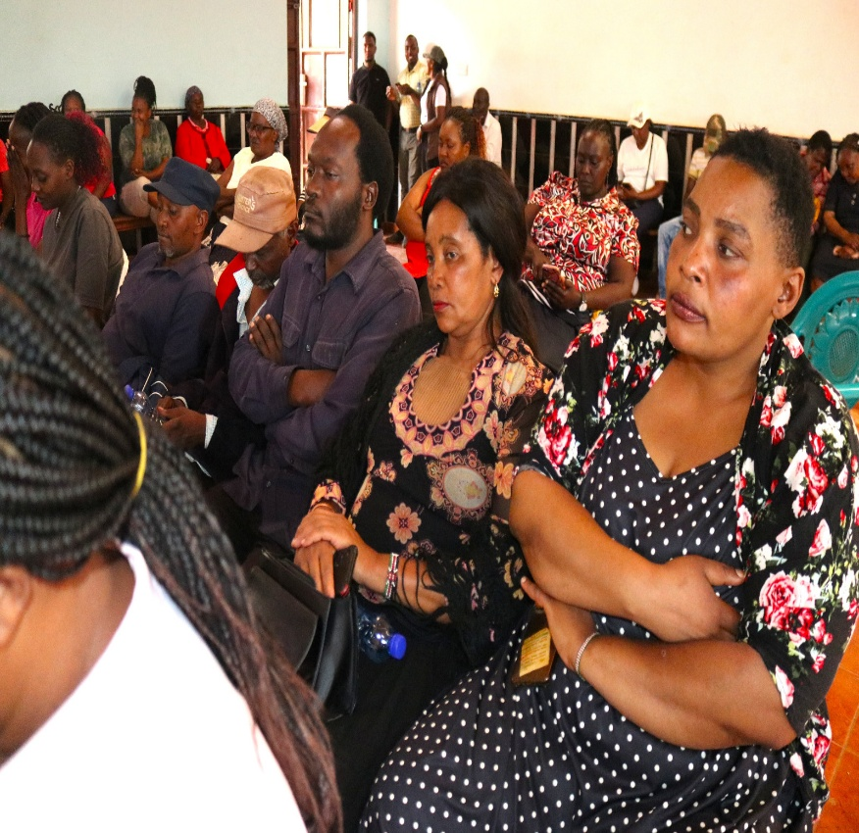 | 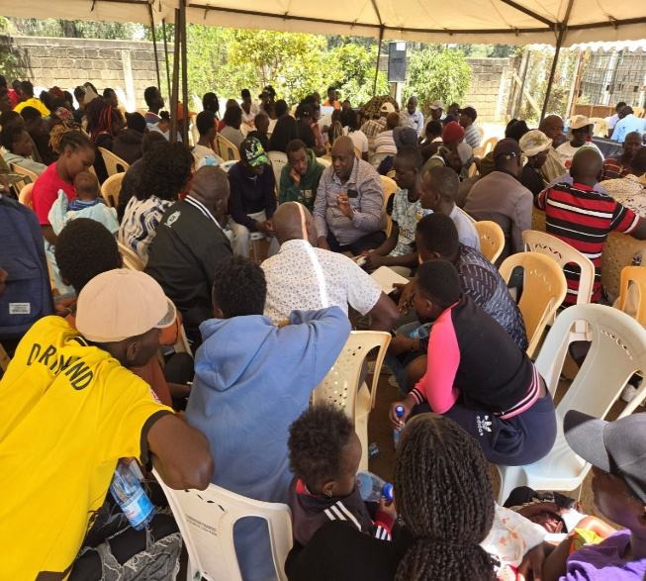
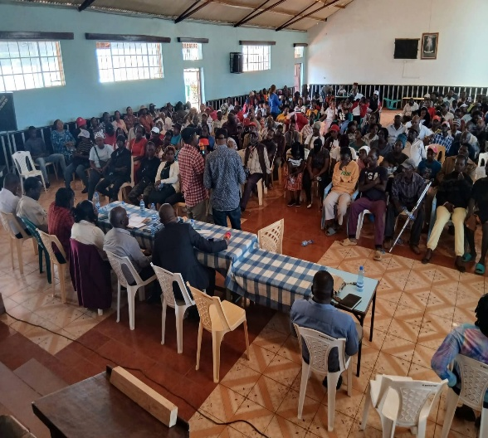 | 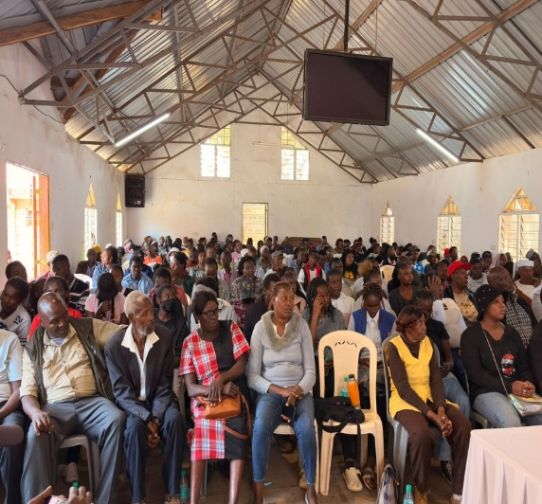

Bajeti Yetu, Wajibu Wetu
County Government of Kiambu — Department of Finance, ICT and Economic Planning
www.kiambu.go.ke | info@kiambu.go.ke | P.O. Box 2344-00900, Kiambu | 0709 877 000

